Lesson 1: What happens when two things hit each other?

Previous Lesson | There is no previous lesson.
This Lesson  Anchoring Phenomenon  3 days   | 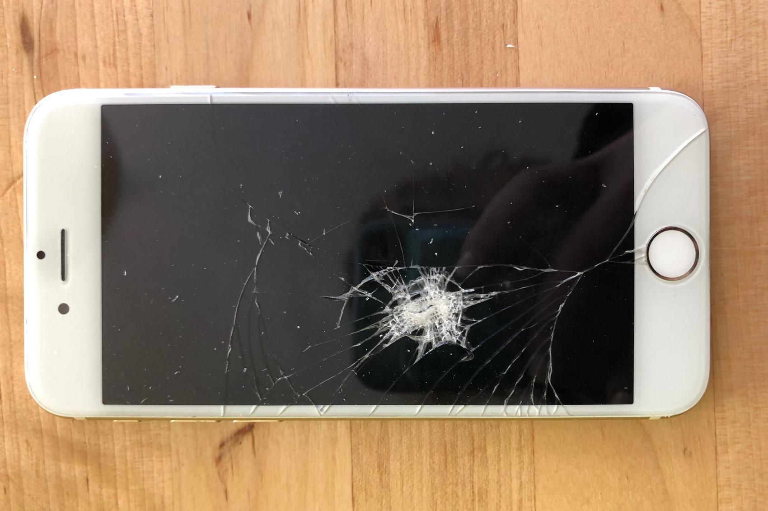 | We share our experiences with cell phones breaking and demonstrate some ways they have broken. We brainstorm related phenomena (other objects that were damaged in a collision and examples where there was no damage). We identify factors and variables that can cause some fragile objects to become damaged more than others. We develop a model to describe visible changes happening to the objects in a collision and nonvisible interactions occurring as well. We develop questions for our Driving Question Board (DQB) and possible investigations we could do to answer these questions.
Next Lesson | We will explore colliding objects and record observations about changes in their motion and shape. We will analyze slow-motion videos of some of these collisions. We will develop a model to represent what we know about energy transfer and forces occurring in collisions when we see changes in motion of objects, shape of objects, or damage to objects.

BUILDING TOWARD NGSS  MS-PS2-1, MS-PS2-2, MS-PS3-1, MS-ETS1-2, MS-ETS1-3, MS-LS1-8   | What students will do  1.A Develop a model to describe interactions between two objects as they collide and show the changes that occur in the structure of both objects when one object is damaged as a result and also when neither object is damaged as a result.  1.B Ask questions that arise from observations of collisions between two objects in order to seek additional information about factors (causes) that might affect the outcome of such collisions.  What students will figure out  - In a collision between two objects, the objects make contact with each other; sometimes something is damaged, but not always.  - Different factors or variables may cause objects to be damaged or not from a collision.

Lesson 1 • Learning Plan Snapshot
Part | Duration |  | Summary | Slide | Materials
1 | 15 min |  | SET THE STAGE FOR A NEW PHENOMENON  Share cell phone damage data from a news article to elicit student experiences. Have some students reenact some phone breaking scenarios. | A-C | 3 blank pieces of chart paper, small stack of blank 8.5” × 11” paper, 2 different color markers, 4 CD cases, 5 sets of goggles, Different Collisions poster
2 | 5 min |  | BRAINSTORMING RELATED PHENOMENA  Classify related phenomena based upon types of collisions and damage or no damage. | D | 2-3 red cards per student, 2-3 green cards per student, Different Collisions poster, Related Phenomena poster
3 | 7 min |  | SHARE AND COMPARE RELATED PHENOMENA  Share related phenomena index cards and compare the interactions with other students. | E-F | related phenomena index cards, Related Phenomena poster, 3 areas of the room labeled “A” “B” and “C”
4 | 6 min |  | SET UP NOTEBOOKS AND STOP AND JOT COLLISION FACTORS  Identify and record variables and factors that affect damage in a collision. | G | Different Collisions poster, Related Phenomena poster, tape
5 | 12 min |  | CREATE INITIAL MODELS  Draw a model to explain the interactions occurring between the objects during a collision and the factors and variables that might contribute to a different outcome (damage or no damage) in a collision. | H-I | Initial Model: Objects During Collisions, Object Interactions During A Collision

End of day 1
6 | 5 min |  | ESTABLISH SCIENTISTS CIRCLE AND SHARE INITIAL MODELS  Share initial model ideas with a partner. | J | Initial Model: Objects During Collisions, Object Interactions During A Collision, tape
7 | 10 min |  | ESTABLISH SHARED NORMS  Develop shared norms for the learning community before the first Consensus Discussion and model. | K | Science Classroom Norms, scissors, tape
8 | 25 min |  | DEVELOP INITIAL CONSENSUS MODEL DISCUSSION AND RELATED QUESTIONS  Develop a whole-group record of what we agree on and where we have competing ideas across the initial models. Record some initial questions for the Driving Question Board. | L-M | Initial Model: Objects During Collisions, Object Interactions During A Collision, markers, Consensus Model for Collisions poster
9 | 5 min |  | DETERMINE FACTORS AND VARIABLES THAT AFFECT DAMAGE  Make a public record of our ideas about what factors and variables contribute to damage in a collision. | N | Factors and Variables poster, markers

End of day 2
10 | 3 min |  | NAVIGATION  Ask students to review the norms again and select a norm to focus on for class today. | O | Science Classroom Norms
11 | 7 min |  | REVISIT FACTORS AND VARIABLES POSTER | P-Q | 1-2 index cards, marker, Factors and Variables poster
12 | 28 min |  | DRIVING QUESTION BOARD AND IDEAS FOR INVESTIGATIONS  Gather in a Scientists Circle to construct a Driving Question Board and develop ideas for potential investigations. | R-S | Initial Model: Objects During Collisions, Object Interactions During A Collision, Driving Question Board, Consensus Model for Collisions poster, index cards, tape, chart paper, markers
13 | 2 min |  | NAVIGATE TO NEXT LESSON  We end the lesson anticipating where we are headed next to investigate this phenomenon. | T
14 | 3 min |  | REVISITING NORMS  Prompt students to revisit how they did on the norms in class today. | U | Science Classroom Norms
15 | 2 min |  | ADD TO THE TABLE OF CONTENTS  Provide an example of how to fill out the table of contents in their notebooks to reference each piece of work they developed so far. |  | chart paper, markers

End of day 3

Lesson 1 • Materials List
 | per student | per group | per class
Lesson materials | - science notebook  - 2-3 red cards per student  - 2-3 green cards per student  - related phenomena index cards  - Initial Model: Objects During Collisions  - Object Interactions During A Collision  - Science Classroom Norms  - scissors  - tape  - 1-2 index cards  - marker |  | - 3 blank pieces of chart paper  - small stack of blank 8.5” × 11” paper  - 2 different color markers  - 4 CD cases  - 5 sets of goggles  - Different Collisions poster  - Related Phenomena poster  - 3 areas of the room labeled “A” “B” and “C”  - tape  - markers  - Consensus Model for Collisions poster  - Factors and Variables poster  - Driving Question Board  - index cards  - chart paper

Materials preparation (25 minutes)

Review teacher guide, slides, and teacher references or keys (if applicable).

Make copies of handouts and ensure sufficient copies of student references, readings, and procedures are available.

Create a Different Collisions poster using one piece of chart paper.

Create a Related Phenomena poster using two pieces of chart paper.
- Include the title “Related Phenomena” at the top.
- Create 3 rows: A, B, and C.
- Write “red = damage” and “green = no damage” in the upper-left corner.
- Up to 3 pieces of chart paper can be used for larger classes.
- Label 3 different areas of the room “A”, “B”, and “C” that allow plenty of space for students to congregate in those areas.

Create a Consensus Model for Collisions poster.
- Include the title “Collisions” at the top.
- Draw a table with 4 columns x 2 rows (plus room for column heads).
- Column #1 head: ”Result”
- List ”Damage” and ”No damage” in the 2 boxes below the ”Result” head.
- Column #2 head: “Time point #1 at the moment of contact”.
- Column #3 head: ”Changes we can see” (in one color) and ”Interactions we cannot see” (in a different color).
- Column #4 head: “Time point #2 a split second later”

Create a Factors and Variables poster with the title “What factors and variables could influence whether a collision causes damage?”. Create the following posters prior to this lesson:

Download the Communicating in Scientific Ways chart from the website and post it in your classroom or add it to students’ notebooks. The file can be used as a poster or as a handout.

Determine where to set up the Driving Question Board so that students can gather around it.

Prepare red and green cards for students to use. This can be made from index cards, construction paper, or sticky notes.

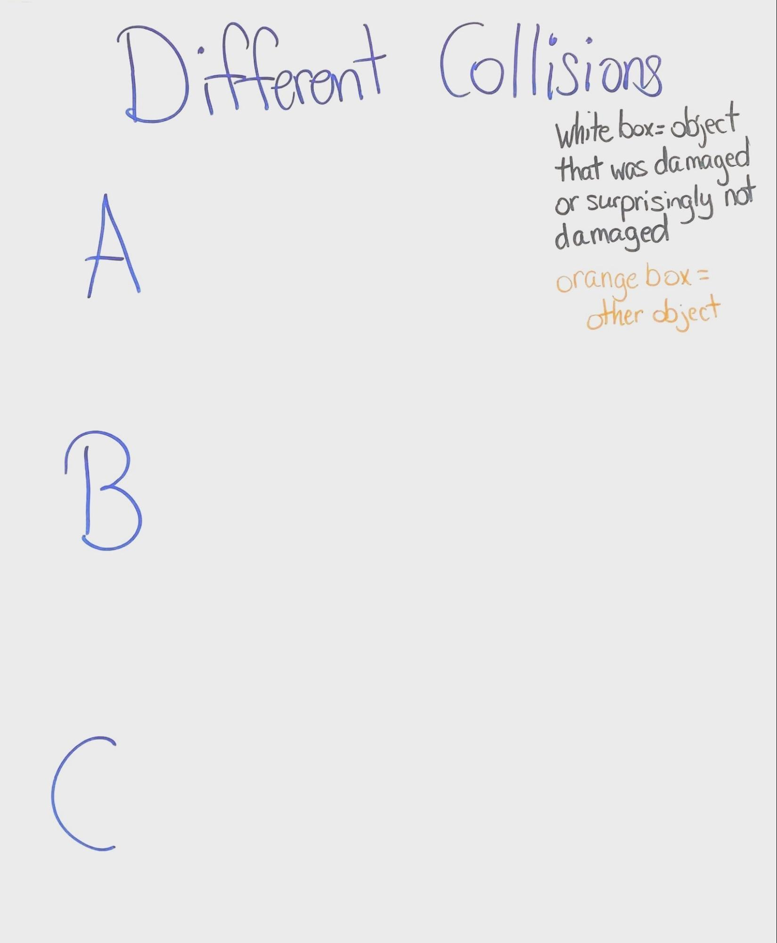 | 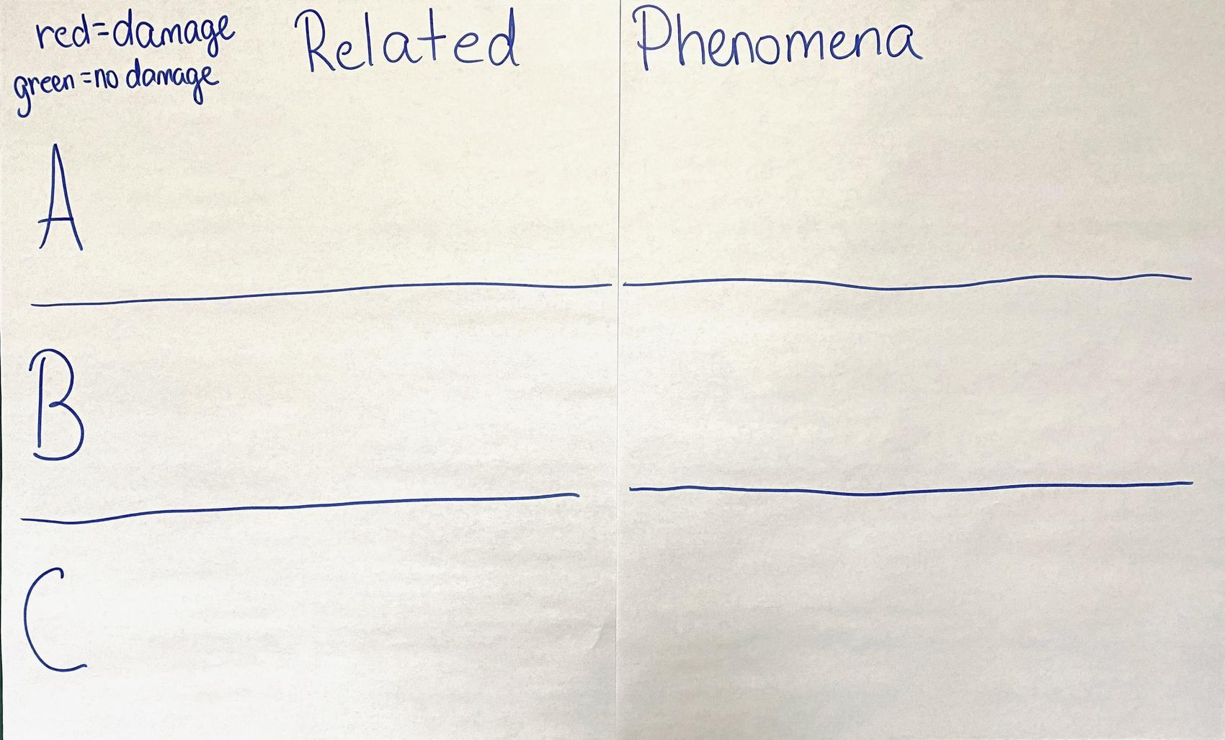 | 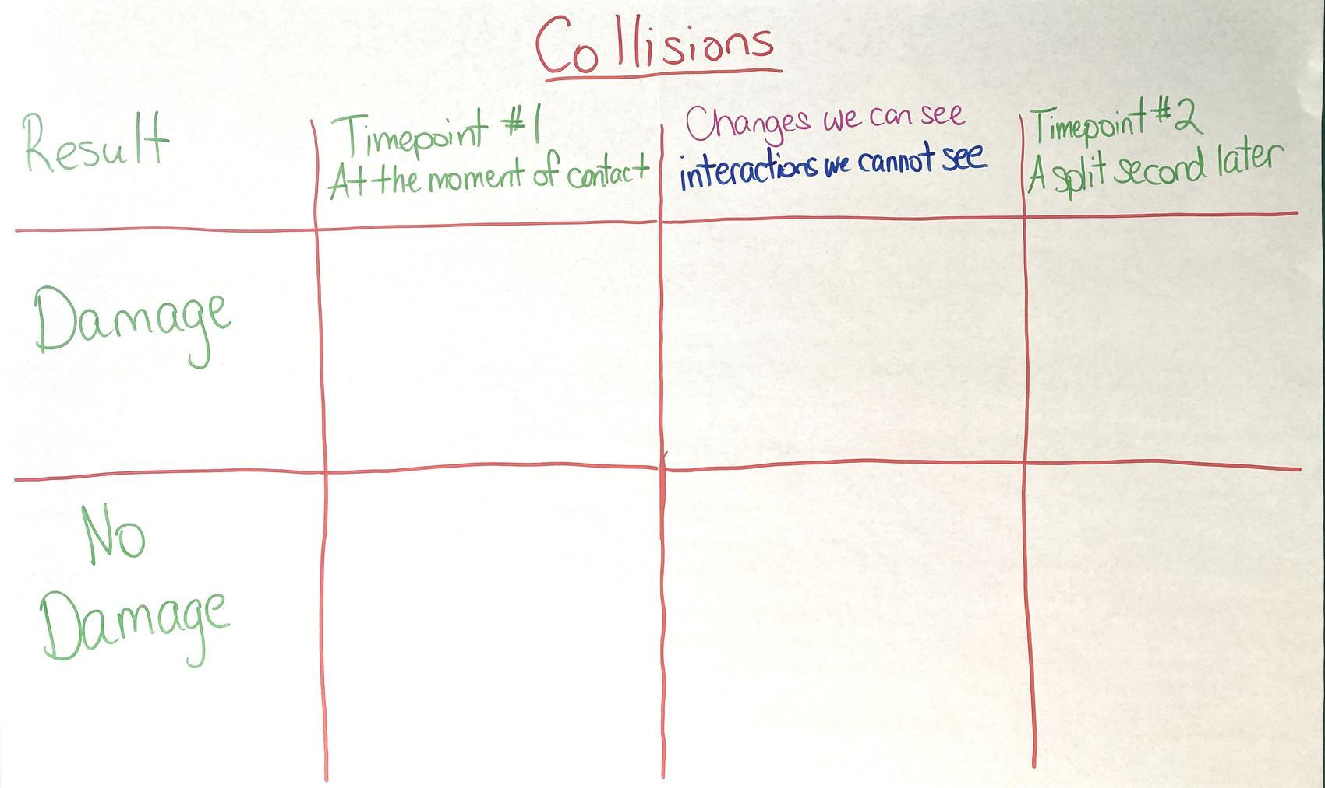 | 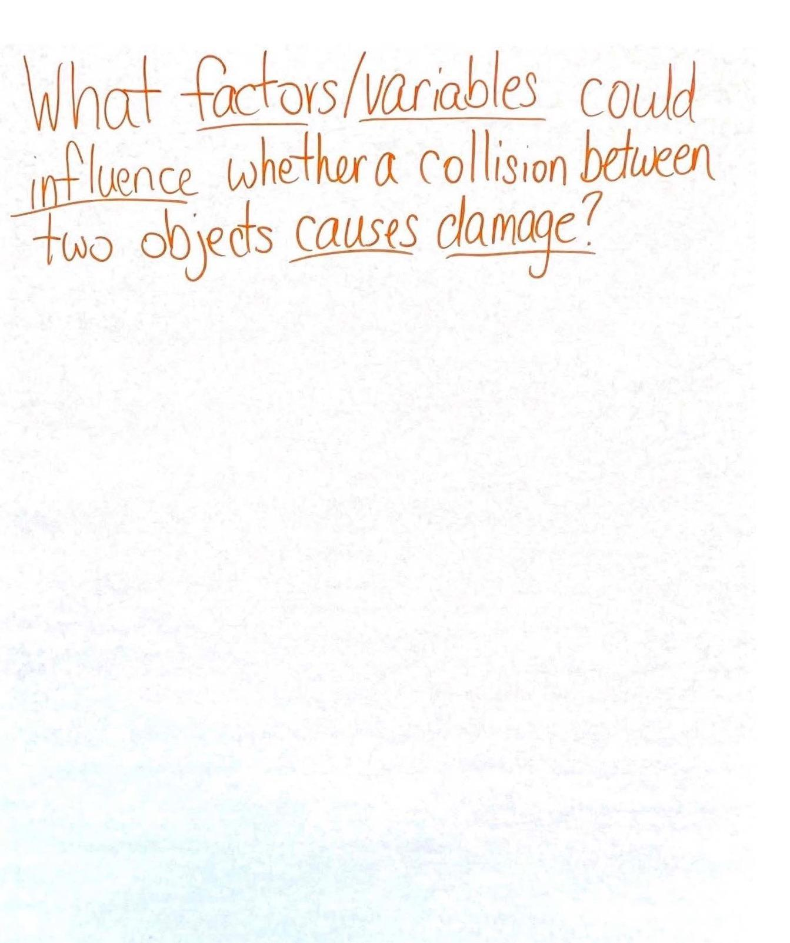

Lesson 1 • Where We Are Going and NOT Going

Where We Are Going

This lesson is meant to draw out students’ prior experiences with collisions and to help them consider what might determine whether something breaks in a collision. This is an opportunity to pre-assess students’ engagement in all three dimensions of NGSS to explain a phenomenon. There are prompts in the initial modeling task that ask students to engage in two elements of the modeling practice related to representing descriptive aspects of the phenomena as well as unobservable mechanisms. Students are prompted to explain the mechanisms that caused the observable changes, which will provide an opportunity to bring related DCIs from prior grades: grade 4 (energy transfer in collisions), grade 2 (objects pull or push each other when they collide), and the middle school grade band explanation (such as equal force pairs between the two objects in contact). There are phrases in the prompts that ask students to consider related elements of CCCs as well, particularly cause and effect, systems and system models, and stability and change.

You may also see some students developing particle-level representations for changes happening to the matter in the system in their initial models, based on their extensive work in developing such models in prior OpenSciEd units: OpenSciEd Unit 6.2: How can containers keep stuff from warming up or cooling down? (Cup Design Unit), OpenSciEd Unit 6.3: Why does a lot of hail, rain, or snow fall at some times and not others? (Storms Unit), OpenSciEd Unit 7.1: How can we make something new that was not there before? (Bath Bombs Unit), OpenSciEd Unit 7.2: How can we use chemical reactions to design a solution to a problem? (Homemade Heater Unit), OpenSciEd Unit 7.3: How do things inside our bodies work together to make us feel the way we do? (Inside Our Bodies Unit), and OpenSciEd Unit 7.4: Where does food come from, and where does it go next? (Maple Syrup Unit).

Students may be curious about which materials are fragile and why or how to protect things that break easily. Students may also be curious about how the motion or mass or size of the objects before the collision affects the outcome. This curiosity will seed future investigations.

Students are likely to identify many of the factors or variables that influence whether an object does or does not get damaged in a collision, such as mass, speed, area of contact, and material type or thickness. The factors and variables identified will motivate many of the subsequent lesson questions and investigations in the first half of the unit.

Where We Are NOT Going

If students do not talk about physics concepts like force, energy, or motion in this first lesson, do not introduce them yet. These words will be explicitly introduced in the next lesson. While this lesson ask students to consider what is happening during contact in a collision, students are not expected to utilize the ideas of positional energy, differences in materials, or elastic limits in their initial models. These ideas will be developed in future lessons. Students may have a partial understanding of energy transfer from Cup Design Unit, Tsunami Unit, Storms Unit, Bath Bombs Unit, and Homemade Heater Unit. While students may represent in their models that this energy transfer is occurring, later lessons will help students understand the relationships among mass, speed, and damage due to the transfer of energy across a medium.

LEARNING PLAN for LESSON 1
1 · SET THE STAGE FOR A NEW PHENOMENON | 15 min
MATERIALS: 3 blank pieces of chart paper, small stack of blank 8.5” × 11” paper, 2 different color markers, 4 CD cases, 5 sets of goggles, Different Collisions poster
Introduce cell phone damage information. Display slide A. Say, I came across some interesting data about cell phone damages. Listen to the things I learned! Read each statistic aloud.  - Americans break 2 smartphone screens every second.  - More than 50 million phone screens are cracked each year.  - An estimated 95 million phones were damaged in the world by dropping them.  - We spend $3.4 BILLION each year in replacing cracked screens--not counting the 38% of smartphone owners who don’t replace them at all.  - 27% of people said that their phone was in a case when they broke it.  Say, This seems like a lot of cell phone damage happening in our world. That got me wondering how common this sort of phenomenon is in our classroom community. Have any of you ever experienced cell phone damage before?  Instruct students to raise their hands if they have experienced a situation where they have seen a phone get damaged.  Elicit student experiences. Display slide B. Ask students to turn and talk with a partner about the slide question: “Have you or someone you know ever broken a phone? What caused it to break? Describe your experiences.”  Say, Wow, we seem to have a lot of experience with damaging cell phones! It sounds like some of you have been the ones to create the damage, and some of you have seen them damaged before.  Introduce a CD case to represent a phone in collisions. Display slide C. Say, I would love to hear about your experiences with phones breaking, but sometimes it's easier for us to understand a situation where something occurred when we can see a representation of how it happened rather than just hearing about it. Phones are expensive, so I have a CD case here that we are going to use as a substitute for a phone. I thought we could use this as a manipulative to represent what happened to the phone when it got damaged.  Demonstrate phone breaking experiences. Select one volunteer at a time to come up in front of the class and demonstrate what happened with the cell phone when it broke. Let students know it's OK if what they show us ends up causing the CD case to break too, as we want to try to understand the interactions that happened and the results as accurately as possible. Remind them to be responsible and avoid moving the CD case or any other object in a direction that might remotely come in contact with another living thing or fragile object.  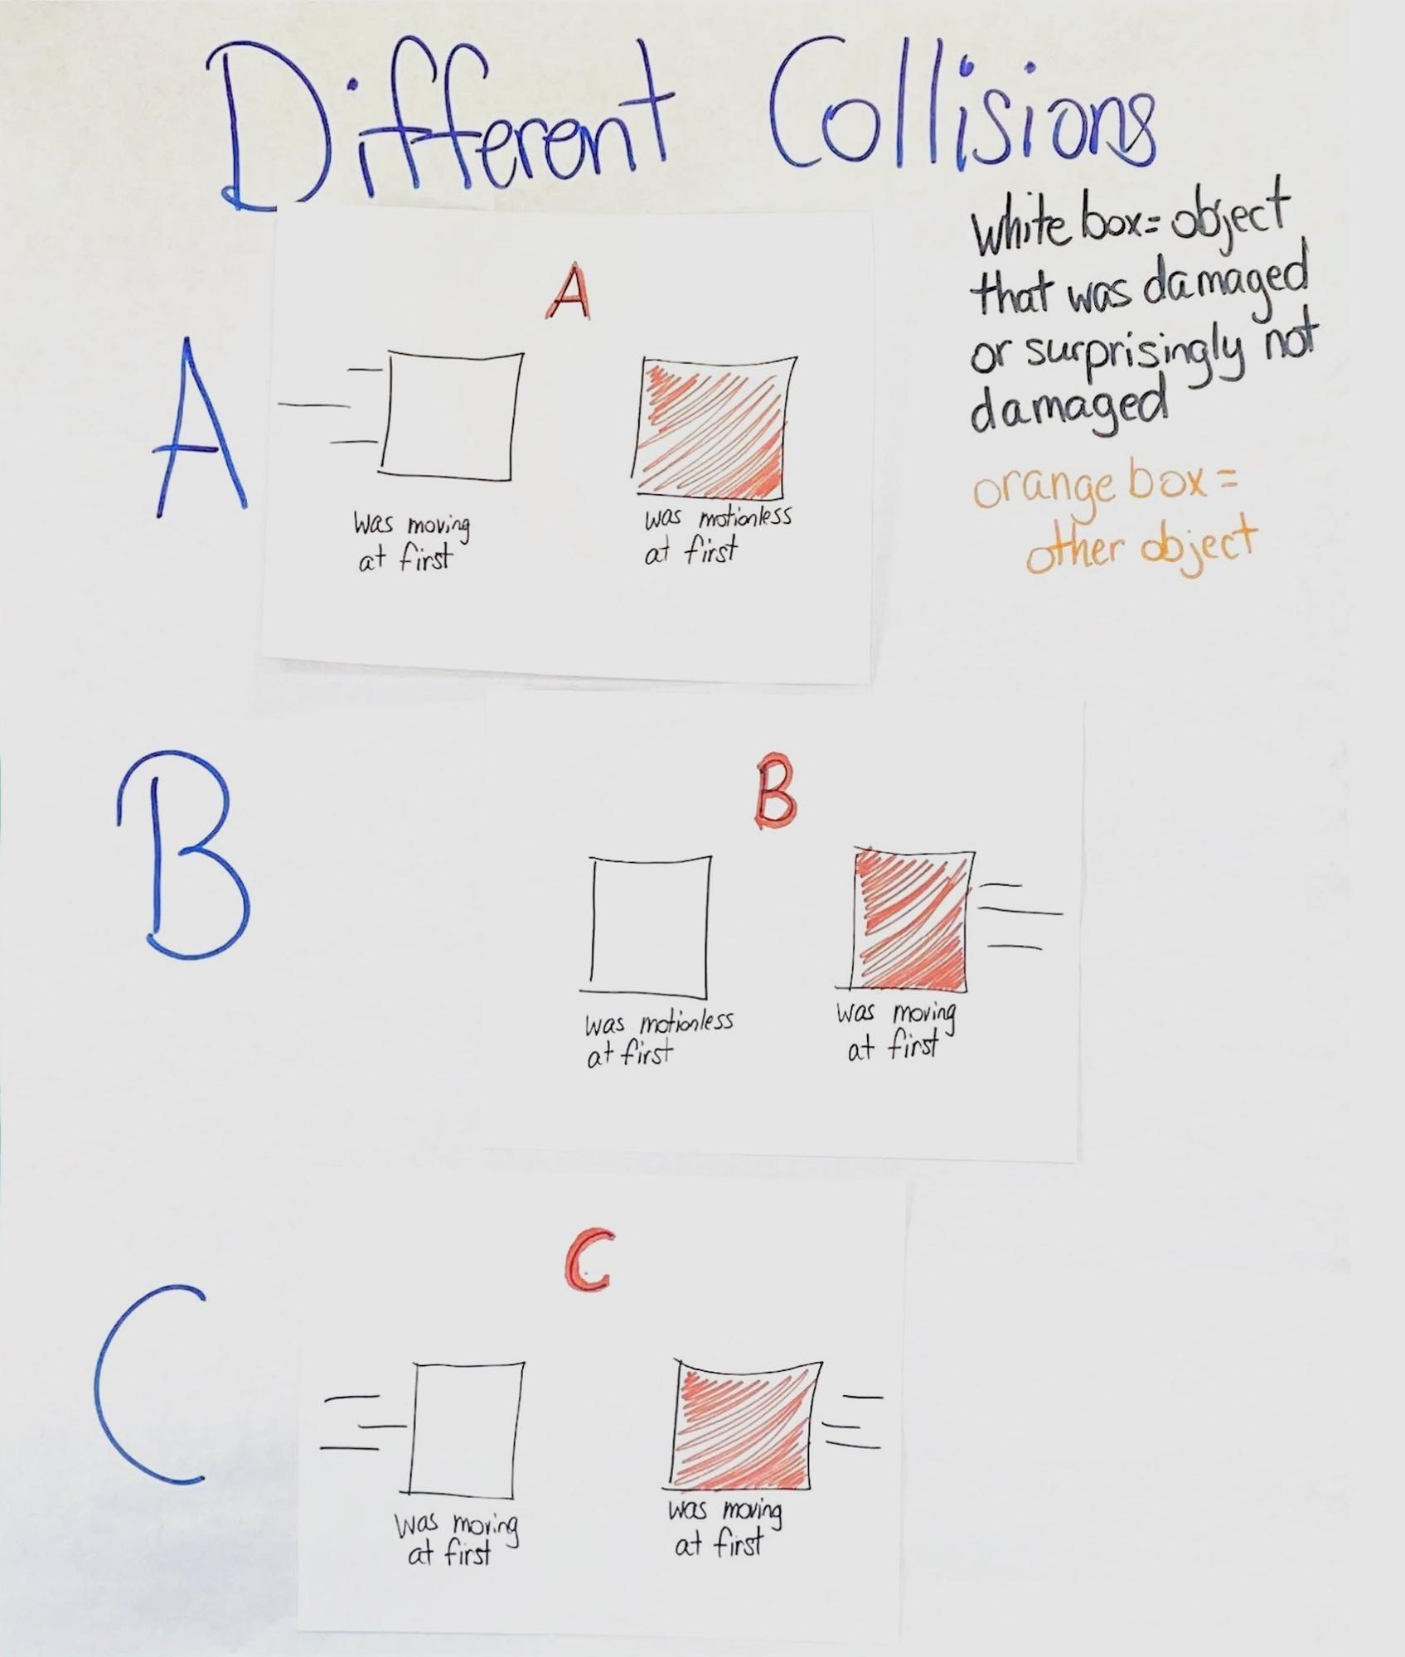  Use the prompts below to elicit experiences from student volunteers so that you get at least one example that would represent each of the three collision types: A, B, and C.  As each student shares their experience, create a diagram on a blank piece of paper using squares to represent the two objects that collided. After creating each diagram, attach it on the Different Collisions poster. Draw large enough for students to see. The diagrams will become part of an anchor chart for students to refer to later. The three diagrams (A, B, C; that you will finish drawing in the subsequent conversation) should be similar to ones shown here. As you are drawing, remember to represent the phone as a white box and the other object as a shaded box instead of the actual objects being described by students. This will help students later to transfer and categorize the general diagrammatic representations into related phenomena experiences.  Discuss and alter frames of reference. Revisit the drawings and place the Different Collisions poster in a spot that is easily viewable for students, if not already in a prominent spot in the classroom. First, remove the piece of paper with collision type A that shows the diagram that has a moving, fragile object colliding with a motionless object (collisions type A). Use the prompts below to help students consider changes to the frame of reference.  Return collision type A back to the Different Collisions poster. If needed, remove the collision types B and C from the Different Collisions poster and repeat this line of questioning with collision types B and C.  Categorize remaining interactions. Ask students if they have any other stories that would be represented differently than our drawings. If a student says yes, have them demonstrate the interaction while you map it out on a blank piece of paper. Compare the interaction to the other collision types on the chart, turning it to see if the interaction matches any existing collision type scenarios. Help students draw the conclusion that the scenario is already on the collision types board by simply changing the frame of reference.  Introduce the word collision to students.✱  Use the CD case, if necessary, to enact the moment when the “phone” touches another object for any of the three collision scenario types.✱  Say, There are a lot of words we can use to describe this phenomenon. When scientists describe this sort of phenomenon, where a moving object hits or runs into another object, they refer to it as a collision.  Display the poster that says “Different collisions”.  Motivate related phenomena. Say, These categories of collisions could be useful for thinking about other related phenomena where something other than a phone was involved in a collision. But not all collisions result in damage. Think of examples where something other than a phone was damaged in the collision. I also want you to think of examples where you were surprised that something other than a phone was not damaged in a collision. | ✱ ATTENDING TO EQUITY  Emergent Multilingual Learners: For students who are learning English or who need support following a whole-group discussion, it can be helpful to use gestures in addition to talking. For example, as you describe a phone hitting a wall, demonstrate the collision by holding a phone (or another object to represent a phone) in your hand and moving it slowly toward the wall.  ✱ ATTENDING TO EQUITY  Emergent Multilingual Learners: A Word Wall will become a useful space for recording a shared meaning of new words as students develop a deeper meaning for them. When developing new vocabulary, some strategies that may benefit emergent language learners are to use student-friendly definitions, make connections to cognate words when possible, and include a visual representation of the word. You have now developed a visual representation of the word collision that you can refer to over the course of this unit. After students have had time to develop a conceptual model or understanding for these words, they will no longer need the visual representation.
  ADDITIONAL GUIDANCE | As students are detailing their experiences, listen for instances where a stationary phone has been hit by a moving object, a moving phone has hit a stationary object (dropped on floor, thrown, and so forth), or a phone that is moving has been hit with another moving object. These instances can be leveraged in the next step for recruiting student volunteers to reenact their experiences.
  ADDITIONAL GUIDANCE | The word damage will be defined later in Lesson 2. At this point, students are identifying collisions that did or did not cause damage, and factors or variables that may contribute to damage. While it is important to develop a common working understanding of this word in later lessons, students' prior knowledge and conceptions of what this word means will suffice for the work in Lesson 1. Students will have an opportunity to develop a deeper understanding of this word in Lesson 2.
  SAFETY PRECAUTIONS   | Review any safety guidelines and have students wear goggles who are demonstrating the collision and standing or sitting near the demonstration during this and all future investigations in this unit. Setting up strong boundaries and expectations with the demonstrations is key. Students will show a variety of collisions with cell phones during this stage. Some possible scenarios to expect are dropping the CD case on different objects, slamming objects onto the CD case, ramming objects into the CD case (e.g., foot, backpack, chair), and flinging the CD case at a wall. Ask demonstration volunteers if the interaction they are about to enact is safe to show with others around and if it can be safely done in the classroom may help ensure safety as students are demonstrating their experiences.
  KEY IDEAS | The purpose of this discussion is for students to determine that there are 3 main types of collisions, and those types may or may not result in damage. As students share their experiences with phones, listen for these three types of collisions to emerge:  - A fragile object moved toward and hit another object that was motionless.  - A fragile object was motionless and was hit by another object that was moving.  - A fragile object was moving and was hit by another object that was moving.  The prompts and example responses below are meant to elicit the three different types of collisions.  What to listen for: Listen for students to give examples of each collision type. Each prompt section below is meant to clarify what was moving and what was not moving. The suggested prompts can be used to ensure that all 3 collision types are present, but if other prompts are used, make sure they elicit experiences, clarify what was moving and what was motionless, represent all 3 types of collisions, and provide for teacher diagram-drawing opportunities.  These collision types will be referenced and leveraged in later lessons to help explain why some objects become damaged, and others are surprisingly not damaged.  Students will get a chance to revisit these ideas and show progress towards figuring this out during the Lesson 6, Lesson 9, and Lesson 13 assessments.
  Suggested prompts | Sample student responses | Follow-up questions
  Most of the interesting figures from the article were about phones getting damaged by dropping them or accidentally throwing them. Does anyone have any examples they can show us where the phone was moving and it ended up hitting something that was not moving? | I dropped my phone down a flight of stairs.  The phone was moving.  Nothing else was moving. It just hit the stairs. | Oh wow! That is not good. I'll try to draw what happened as you show us how it happened. What was moving?  So the stairs were motionless?  So it sounds like we have a fragile object moving toward and hitting something motionless. Cool. Let’s label this collision type “A”.  (Draw representation A for this scenario.)
  Are there any examples where things were moving and then damaged the phone? Is the phone always the thing that is moving when it gets damaged, or can it be motionless and get hit by something else moving? | Something else can be moving and hit it to make it break, like when I accidentally dropped my book bag on top of my phone.  The bag was moving.  The phone was not moving. | Wow that’s interesting! Show us what happened. Let me draw this out so we can all see what happened as you show us. What was moving?  Was the phone not moving?  So the moving book bag hit the nonmoving, fragile phone, correct? Awesome. Let’s call this type B.  (Draw representation B for this scenario.)
  Are there any other instances where things were moving to damage the phone? Does every phone-breaking story have one thing that wasn’t moving, or can both things move and run into each other to cause damage? | Two things can definitely run into each other to cause damage!  (Some students will likely raise their hand.)  I saw a video of someone throwing a phone like a baseball and it getting hit with a baseball bat. It did not turn out well for the phone.  Both objects were--the bat and the phone.  Yes. | (Poll students.) Has anyone ever had this happen to them or seen this happen? Raise your hand if this has happened to you or someone you know.  Does anyone have an example they would like to share where both the phone and something else were moving and hit each other to cause damage?  That sounds like it really got damaged! Show us what happened. Let me draw this one too. What was moving?  So everything was moving?  OK. Let’s write type “C” on this piece of paper.  (Draw representation C for this scenario.)
  Suggested prompt | Sample student response
  Look at this diagram we drew of the collision type that went with our phone facts we read. It shows the moving phone coming in from (specify direction) before hitting an object that is not moving. Would this still show the same type of interaction if I rotated the picture to the left?  (Rotate the diagram clockwise.) | Yes, because the phone is still running into something that is not moving.
  Do we still have the same thing moving and the same thing motionless before they hit? | Yeah, it still has the phone as the only thing moving before it hits the other thing. The same objects are still moving and not moving.
  What if I rotate it to the left one more time? | You still have one object moving into another object. It’s the same.
  So even if we change the direction, we still have the same object moving and the same object motionless? | Yeah, the same object is moving, it's just coming from a different direction.
  ADDITIONAL GUIDANCE | If students bring up the idea of gravity, acknowledge the idea by saying:  So it sounds like you are thinking about forces in the system too. That is a really useful way to consider what is happening in any system where we are tracking motion of objects in the system. Right now our diagrams are only showing which objects are in motion before the collision to see if we can classify all our collisions in terms of which objects were in motion at first. We may need to consider how to add forces if we think that is helping explain something about the collision too.  In later lessons, gravity will be used to provide a force to move carts on a ramp for data collection purposes. While gravity is not being addressed or explained in this unit, the force of gravity will be recognised and utilized.
  KEY IDEAS | Part of the DCI for PS2.A states that, All positions of objects and the directions of forces and motions must be described in an arbitrarily chosen reference frame …. In order to share information with other people, these choices must also be shared. The idea of an arbitrarily chosen reference frame was introduced here when you physically rotated the diagrams and asked students whether the diagram still represents the same system. You are further reinforcing this idea by asking whether all the other collisions can be categorized using one of three system diagrams (A, B, and C).
  Suggested prompt | Sample student response
  We’ve talked about our experiences and made some observations about what happens when a phone gets damaged. I’ve noticed we’ve all been using different words to describe that moment when the objects hit or run into each other. Can someone share another word that they have been using to describe this? | Smash.  Bump.  Crash.

2 · BRAINSTORMING RELATED PHENOMENA | 5 min
MATERIALS: science notebook, 2-3 red cards per student, 2-3 green cards per student, Different Collisions poster, Related Phenomena poster
Document related phenomena on index cards. Project slide D. Read through the directions on the slide. Pass out 2-3 red and green index cards to each student. If red and green cards are not being used, update slide D and slide E to reflect the colors of the index cards or sticky note being used.

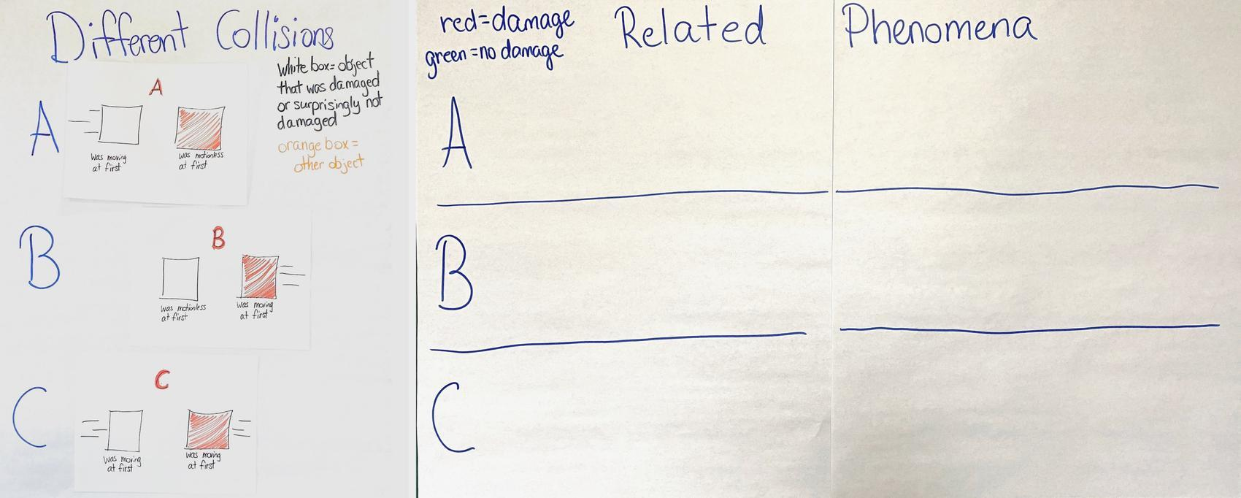
Prompt students to record at least one collision where something has been damaged on red cards and at least one collision where something was surprisingly not damaged on green cards. For each thing listed, students should identify the objects that came into contact with each other during the collision and underline the object or objects that were moving before the collision occurred. Only one collision example should be written on each card.

Provide students approximately 5 minutes to generate and record their related phenomena cards. Encourage students to use as many cards as they need as they think of other examples.

Hang the Different Collisions poster to the left of the Related Phenomena poster. Then, circulate during the remaining time to help any student who may become stuck while trying to brainstorm examples.

With about a minute left, remind students to go back over their cards and make sure that they have identified the objects that came into contact with each other during the collision and have underlined which objects were moving before the collision occurred.

3 · SHARE AND COMPARE RELATED PHENOMENA | 7 min
MATERIALS: science notebook, related phenomena index cards, Related Phenomena poster, 3 areas of the room labeled “A” “B” and “C”
Revisit the different collision types. Display slide E. Read through slide E and go over each type of collision, emphasizing what objects were moving or not moving before the collision. A quick reference table is given below.  Say, In class we have identified three different types of collisions. Let’s sort our related collisions into these categories and see if we notice any patterns or factors that may contribute to damage in the collisions. Look at your index cards and write the collision type at the top of each one--A. B. or C.  Have students ask an elbow partner to quickly check their collision types. If there is debate on the collision type, help students sort out the appropriate type individually.  Share related phenomena. Display slide F. Students will organize themselves based upon related phenomena and share their phenomena with a partner.✱ During this time students will be developing the idea of different factors or variables that impact damage.  Say, In a moment, you will get the chance to share your related phenomena with someone else. There are 3 sections of the room labeled A, B, and C. When I ask you to, you will look at the collision type on one of your cards and go to the area with that collision type. Once you are there, find someone and share your collision. As you share, be thinking about what is similar and different between the two collisions.  Ask students to look at one of their red, damage cards first. Direct them to move to the area of the room that matches their collision type. Give students 2 minutes to share and compare and contrast with their partners. After the two minutes are up, ask students to look at one of their green, no-damage cards. Direct students to move to the area that matches their green card collision type. Give students 2 minutes to share and compare and contrast with their partners.  Tell students to hand in all of their index cards and return to their seats. | ✱ ATTENDING TO EQUITY  Universal Design for Learning: It is important to organize activities in ways that create opportunities to support student engagement in meaningful, accountable talk by emphasizing socially safe activity structures (e.g., small-group or partner work before a whole-class discussion). This is especially beneficial to emergent multilingual students. For this reason, partner talk or small-group talk should precede whole-group sharing to give students an opportunity to share their ideas with one or two peers before going public with the whole class.
  Collision type | Motion of the objects before the collision and the resulting damage
  A | A moving object was damaged OR wasn’t damaged when it collided with a motionless object.
  B | A motionless object was damaged OR wasn’t damaged when a moving object collided with it.
  C | A moving object was damaged OR wasn’t damaged when it collided with another moving object.

4 · SET UP NOTEBOOKS AND STOP AND JOT COLLISION FACTORS | 6 min
MATERIALS: science notebook, Different Collisions poster, Related Phenomena poster, tape
Prepare science notebooks. Say, It seems like we were finding a lot of similarities, differences, and maybe even some important factors and variables across our collisions. Let’s make sure to record these ideas!  Identifying factors in a collision. Project slide G. Ask students to begin a new page in their science notebook to set up the related T-chart.✱ Give students 4 minutes to record any patterns they saw in the collisions they discussed.✱ Have students focus on looking for clues about possible factors or variables that would cause something to get damaged or not get damaged during a collision and record them on their charts. Some potential ideas for factors or variables include the following:  - mass of the object  - speed of the object  - direction of the object  - if the object was moving or not  - angle at which the object was struck  - material the object is made from  Organize related phenomena. While students complete their tables, use this independent writing time to tape the student-generated phenomena cards in the correct areas on the Related Phenomena poster. For larger classes, it is recommended to use 3 pieces of chart paper instead of 2 pieces to accommodate space for all index cards on the poster. | ✱ ATTENDING TO EQUITY  Universal Design for Learning: Keeping a science notebook allows students a space in which to reflect and communicate their developing understandings about science ideas and to track changes in their understandings. Students should be encouraged to record their ideas using linguistic (e.g., written words) and nonlinguistic (e.g.,taping in photographs, creating drawings, tables, graphs, mathematical equations, and measurements) modes.  ✱ ATTENDING TO EQUITY  Supporting Emergent Multilinguals: This is especially important for emerging multilingual students because making connections between written words and nonlinguistic representations helps students generate richer explanations of scientific phenomena.
  SCIENCE NOTEBOOK   | If this is the first unit of your 8th grade course and you have not yet set up and organized students’ science notebooks, you need to include additional time to do so now. Have students organize their notebooks using a format that will be easy for them and you to maintain across the year. Helpful tips for keeping the notebooks organized include the following:  - Number pages so that students can easily refer to their work (e.g., models, data sets) during collaborative discussions.  - Maintain a table of contents and update it throughout the unit. Reserve at least 4 pages (2 sheets front and back) for the table of contents for a single unit. The table of contents can be at the front of the notebook for all units within or at the beginning of each new unit within the notebook.  - Give each page a recognizable title that can be added to the table of contents after those artifacts are added to the notebook (students will do this at the end of this lesson).  - After the table of contents, reserve the next 20 pages (10 sheets front and back) for their Progress Tracker for the unit. This is the place where students will individually reflect on their progress and also add key consensus modeling work completed by the class.  For more information on Science Notebook Management, refer to this section of the OpenSciEd Teacher Handbook.
  ADDITIONAL GUIDANCE | In previous units, students have had experience identifying variables that can affect a system. The connection between variables and cause and effect have been woven into multiple units, including Cup Design Unit and Homemade Heater Unit. There are multiple factors or causes for this phenomenon that influence its outcome, and this chart helps students identify variables to change in later lessons. If students are struggling with coming up with variables or factors that might have contributed to damage or no damage in a collision, lessons where variables have been altered from previous units can be referenced for ideas. One specific lesson to reference includes changing variables within the cup system to affect the retention of energy from Cup Design Unit. Cause and effect can also be seen in Tsunami Unit where wave energy resulted in damage to breakwaters in a collision. Students may bring ideas from these units to aid them in their explanations and determination of factors and variables in a collision.
  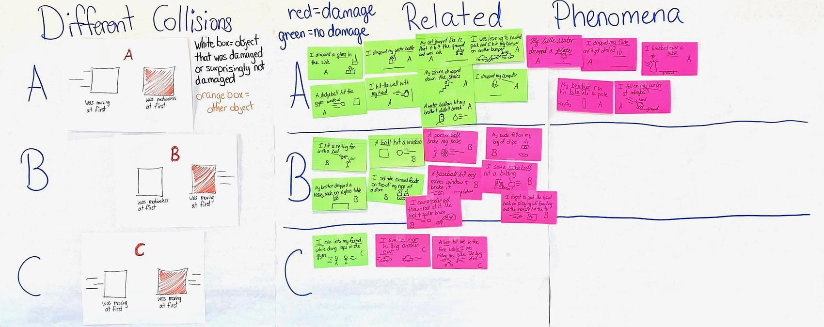

5 · CREATE INITIAL MODELS | 12 min
MATERIALS: Initial Model: Objects During Collisions, Object Interactions During A Collision, science notebook
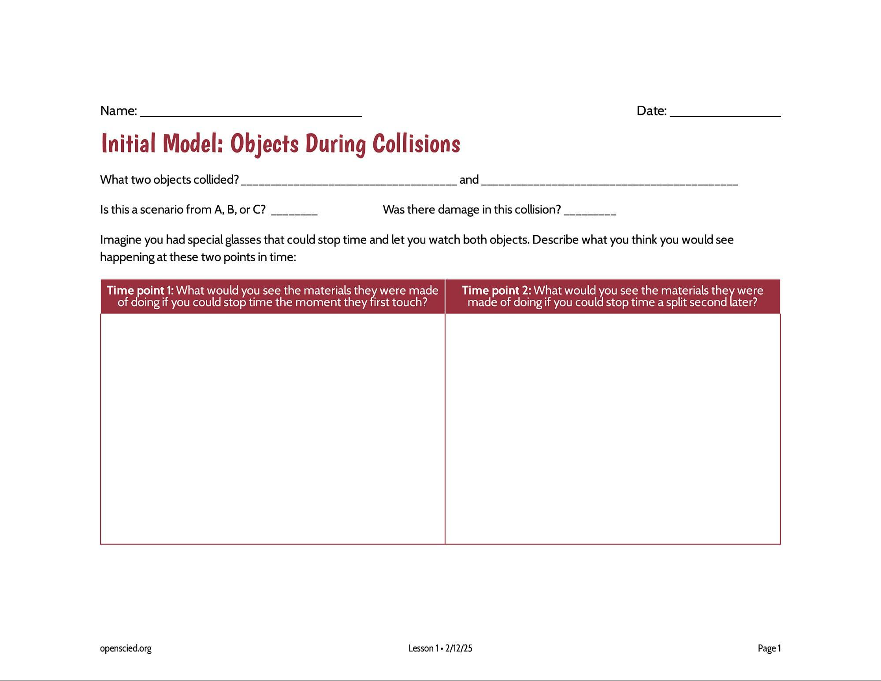  Develop initial models of objects during a collision. Say, Let’s try to develop a model to explain what is happening when two things come into contact in a collision. Display slide H.✱  Distribute a copy of Initial Model: Objects During Collisions to each student. Tell students that they should put their name on their handout but don’t add it to their notebooks yet, as you want to collect it at the end of the period to get a sense of what they are thinking. Ask students to look at the Related Phenomena poster where they listed examples of things that have been damaged or surprisingly not been damaged in collisions. Ask students to pick one of these examples to explain on their handout.  Say, You are going to use this handout to develop a model to show what interactions are happening between the objects during a collision. On the first line, list the two objects that collided. Did you choose an example that matched collision type A, B, or C? List which scenario you chose. Look at the next question: Was there damage in this collision? Write “yes” if there was damage and “no” if there was not damage. Give students a minute to answer the first three questions on their handout before moving on to the boxes below.  Say, In the space below, imagine you could slow time down and could also freeze or pause the collision at different points in time. What do you think you would see happening to the materials right at the moment the objects first touched or made contact with each other in the collision? That’s this box on the left labeled “Time point 1”. How about a split second later? That’s the box on the right labeled “Time point 2”. Draw and label or describe in words what you think you would see happening for both objects at each time point.  After 3-4 minutes, distribute Object Interactions During A Collision. Project slide I. Say, Look at the questions on this second handout and look at the model you just drew. The first question is asking you to think about what is happening with the objects between time point 1 and time point 2. What changes do you think you could see happening between those two points in time?  The second question asks you to think about the interactions that you cannot see happening with the objects in a collision. What interactions between those two points in time do you think you couldn’t see happening with those objects as they collided?  The third question wants you to think about what changes to these interactions might lead to more or less damage. When we are talking about their interactions, we are talking about the ways that they are acting on and affecting each other when they are touching. What changes to the way that they are acting on and affecting each other when they are touching would lead to more or less damage?  Give students the remaining time to consider the questions and respond.✱✱ At the end of the class period, have students hand in Initial Model: Objects During Collisions and Object Interactions During A Collision for a formative assessment. If students have constructed the initial models in their notebooks, have students hand in their notebooks. | ✱ SUPPORTING STUDENTS IN ENGAGING IN DEVELOPING AND USING MODELS  1. The word model means something specific in this context that it might not mean for students in other contexts. Remind students that in this classroom, a model is a picture and/or description that helps us explain something that happens in the world. We are asking students to make a model to help explain why something gets damaged when it is involved in a collision. Like their work in previous OpenSciEd units, such models should be trying to do more than just show what we can see, they should also try to represent any unobservable mechanisms that we think might be at work in the system.  2. Students take into account multiple factors that may contribute to damage in a collision. While it will be relatively intuitive for some students to attend to the ideas of variables changing in the system, some changes that are unobservable at the micro level must also be occurring. This focus on unobservable mechanisms is where students will likely need additional encouragement to make their thinking visible on paper. Such prompting is more likely to raise awareness that there is a gap in the current explanatory model (if the student can’t think of any candidate mechanisms), or it may also help them connect to previous ideas about forces or energy they may have developed though prior instruction.  ✱ SUPPORTING STUDENTS IN DEVELOPING AND USING STABILITY AND CHANGE  Modeling and explaining visible changes provides students the opportunity to show understanding of Stability and Change. Grades 3-5 experiences should have accentuated that although some systems appear stable, they can change over time. By asking questions that allow students to dwell on the moment of impact and what happens shortly after the collision, prior conceptions about instantaneous damage can be uncovered. Students may believe that shape changes do not happen unless there is damage, or damage is only limited to the breaking of objects. At this point students are not expected to exhibit understanding of these ideas nor do they need to show changes at different scales (including the particle level) that occur over the duration of the collision. Over the course of the unit, students will develop an understanding of shape change that occurs during collisions, force pairs, and the interactions of objects in a collision.  ✱ SUPPORTING STUDENTS IN THREE-DIMENSIONAL LEARNING  This is an opportunity to pre-assess students’ engagement in all three dimensions of NGSS to explain a phenomenon. There are prompts in this task that ask students to engage in two elements of the modeling practice related to representing descriptive aspects of the phenomena as well as unobservable mechanisms. Students are prompted to explain the mechanisms that caused the observable changes, which will provide an opportunity to bring related DCIs from prior grades: grade 4 (energy transfer in collisions), grade 2 (objects pull or push each other when they collide), and the middle school grade band explanation (such as equal force pairs between the two objects in contact). There are phrases in the prompts that ask students to consider related elements of CCCs as well, particularly cause and effect, systems and system models, and stability and change.
  ADDITIONAL GUIDANCE | If students need more room for their diagrams, you can have them record their ideas in their notebook directly instead of on the handout. They can take an entire notebook page turned sideways for their time point 1 and 2 drawings and use the facing page for their explanations. Note that this will take up two notebook pages instead of one.
  ASSESSMENT OPPORTUNITY | Building towards: 1.A Develop a model to describe interactions between two objects as they collide and show the changes that occur in the structure of both objects when one object is damaged as a result and also when neither object is damaged as a result.  What to look for/listen for  - Unobservable mechanisms: Prompts in this task ask students to engage in two elements of the modeling practice related to representing descriptive aspects of the phenomena as well as unobservable mechanisms (energy transfer in collisions and objects pushing on each other when they collide). You may also see some students using particle-level representations to help explain changes occurring in the objects in the collison, based on their extensive work in developing such models in prior OpenSciEd units.  - Factors or variables that cause the materials to break or not break in a collision, such as mass, speed, area of contact, material type and thickness, any other structural differences students wish to identify  - Other connections to CCCs: There are phrases in the prompts that ask students to consider connections to related elements of CCCs, particularly cause and effect, systems and system models, and stability and change. These may lead students to develop and use ideas that help them connect ideas about forces, energy, and changes occurring in the object. These ideas will be developed later in this unit. Here is a good opportunity to see if students are already making some of these connections:  - In a collision objects exert forces on each other; those forces cause energy to be transferred (effect) to or from the objects.  - Each object in the collision (subsystem) exerts a force on the other object in the collision; these forces are equal in strength and opposite in direction.  - These forces (cause) also result in some deformation (change or effect) of each object.  - An object’s structure (the type of materials it is made of and the shapes of those materials) affects how much it will deform and how much it will push back in a collision before breaking.  - Deformation beyond a certain point results in damage (a permanent shape change); but deformation below that point does not (stability).  - The amount of kinetic energy objects have in a system is related to the amount of energy that can be transferred between them and the amount of peak force they will apply to each other in a collision; the amount of kinetic energy is related to the mass and speed of the object.  What to do: If students do not include connections to any of these ideas listed above, that is OK for now. Students will build on and revise their models over the course of the unit. Make a copy of these explanatory models and compare them with what students show in their individual model and explanation at the end of Lesson Set 1 and the end of Lesson Set 2. You may also want to have students analyze their growth by comparing these artifacts related to the elements mentioned above.

End of day 1

6 · ESTABLISH SCIENTISTS CIRCLE AND SHARE INITIAL MODELS | 5 min
MATERIALS: Initial Model: Objects During Collisions, Object Interactions During A Collision, science notebook, tape
Return materials to students. Return Initial Model: Objects During Collisions and Object Interactions During A Collision to science notebooks to students. If students used the loose handouts instead of recording in their science notebooks, give students time to attach the handouts to a notebook page using tape.  Form a Scientists Circle for the first time. Ask students to assemble their chairs in a circle and to bring their science notebooks and something to write with. Students will remain in the circle for all of class, though they will move among partner, small-group, and whole-class discussions. This will help minimize the movement of chairs throughout the class period. As students get more comfortable with the Scientists Circle, they can move between it and other activity structures more quickly. Ideally, they will need to be able to see the slides and have access to a whiteboard, but if that is not possible, use only the whiteboard (or chart paper), which is where the more critical sensemaking will occur for the rest of the class.  Share initial models with a partner.✱ Display slide J. Ask students to keep track of similarities and differences between (1) what they think would happen at each point in time for each model and (2) the factors and variables that may have contributed to damage or no damage. | ✱ ATTENDING TO EQUITY  Supporting Emergent Multilinguals: Before students engage in whole-class discussions, it can be helpful to first provide them with the opportunity to work with others--either in pairs, triads, or small groups--on ideas related to their reasoning. These smaller group structures can be especially helpful for emerging multilingual students because they offer students a chance to engage in sensemaking with their peers and also the space to use their linguistic and nonlinguistic resources to express their ideas (and learn from other students’ uses of these resources too).
  SCIENTISTS CIRCLE   | You will form a Scientists Circle in many future lessons as well. Setting up the norms and logistics for forming, equitably participating in, and breaking down that space is important to do if this is your first time forming such a space. Having students sit in a circle so they can see and face one another can help build a sense of shared mission and community of learners working together. Returning to this Scientists Circle throughout the course of the unit to take stock of what the class has figured out and where they need to go next will be an important tool in helping the class take on greater agency in steering the direction of their learning. This circle will also help build a sense of pride in their work. You may want to inform students that professional scientists also collaborate with one another to brainstorm, discuss, and review their work.

7 · ESTABLISH SHARED NORMS | 10 min
MATERIALS: Science Classroom Norms, science notebook, scissors, tape
Introduce the idea of coming to consensus as a class. Tell students, Soon, we’ll try to come to agreement with all our diagrams. The purpose of introducing the consensus task before talking about classroom norms is to get students thinking about how difficult it will be to get all members of the learning community to agree and how we want to make sure everyone is included and all voices are heard.  Introduce science classroom norms. Tell students that before the class moves on with further investigations, it is time to set up some norms for how the class wants to work and learn together. You may want to reiterate productive behaviors you witnessed in the first day of Lesson 1 as a way of communicating to students that they were already operating using some positive norms, but they had not yet talked about them.  Display slide K and pass out the handout Science Classroom Norms. Note: Edit the handout and slide as desired for your classroom.  Remind students that in prior units we have used norms to help develop a productive and respectful learning environment. They are similar to rules but are intended to ensure that all students have a positive learning experience in science class.  The norms on the handout and the slide are a starting point for the class.✱ It is important to talk through each one with students and ask them to provide an example or paraphrase the norm. The purpose of this is to develop a shared understanding of each norm. Also, provide opportunities for students to clarify a norm, ask for a modification, or develop a new norm. Allow students to write on their handouts if the class decides to change something. Norms are intended to be shared by the students and teacher, so even though a set has been provided, it is just a starting point.  Choose a norm to work on today. Ask students to read through the norms one more time, nominate one norm that may be particularly hard to follow, and suggest a strategy that could help everyone adhere to it. Then, before the students end their conversation, ask them to silently pick one norm from the sheet that they personally will work on today. Give them at least 30 seconds of quiet, individual think-time to make this decision. | ✱ ATTENDING TO EQUITY  Universal Design for Learning: It is important to use this norm-building time to begin to cultivate an equitable learning community that promotes trusting and caring relationships that foster student engagement. The norms should remind students to value the diversity of classroom community members and equity in the sensemaking work they will do together this school year. It is critical that the norms support safe and fair participation and interrupt cultural norms or stereotypes that could make science experiences feel uncomfortable to students (e.g., being someone who is not intelligent enough to think like a scientist, who cannot do the relevant math, who cannot share their thinking).
  ALTERNATE ACTIVITY | When setting up learning community norms, students should understand how norms help everyone in the community understand what is expected of them. Here are two approaches to setting up norms:  - Give students a set of norms as a starting point (the default approach written in the learning plan). Share a set of community norms with students and provide space for students to edit or add to the norms if they believe something is missing.  - Co-construct norms with students (the alternate approach). Explain what norms are and why we need them for productive science talk and classroom culture. Have students co-construct norms, first sharing ideas in small groups and then sharing with the whole class. Compile a list of agreed-upon classroom community norms. As the teacher, you can add norms that may be missing from the list. Make sure to explain to students how you think the norm you added is helpful so that they are clear about why you are adding it to the list.  Consider the following questions, which can help you determine which approach is best for your situation:  - Do you want students to participate in co-constructing the norms?  - Do you want the same set of norms for every section of science you teach?  - Do you want to work with your team teachers to establish a shared set of norms for students across all your classes?  - What kinds of consequences will you enforce if students do not follow the norms?
  ADDITIONAL GUIDANCE | Before moving on to the next step, let students take a moment to cut and tape the handout into their notebook (or you can wait until they break from the Scientists Circle and return to their desks). If there are many edits, you may choose to modify the document and reprint it for students before they tape it into their notebooks. It will be important for the norms to appear early in their notebook. Consider taping it to the inside cover of the notebook so that it is easily and often seen by students. Also be sure to have a public place where the norms are posted on the wall for students to reference.

8 · DEVELOP INITIAL CONSENSUS MODEL DISCUSSION AND RELATED QUESTIONS | 25 min
MATERIALS: Initial Model: Objects During Collisions, Object Interactions During A Collision, science notebook, markers, Consensus Model for Collisions poster
Share initial models in the Scientists Circle. Display slide L. Arrange students around the Consensus Model for Collisions poster.  Say, Let’s start with a model of when the objects in the collision did have damage. Let’s have a couple of people share their ideas with the class.  Pick two students with different models from Initial Model: Objects During Collisions to come up and show their models to the class. Try to pick examples that look different than the others. Tell students that as their classmates share their models, they should place a small check mark (✓) near what is similar and a question mark (?) near what is different on their own model. Ask students to explain what they think is happening that we can and cannot see between the two objects.  Lead a Consensus Discussion to create an initial consensus model. Use the Consensus Model for Collisions poster to incorporate the areas on which we agree. Allow students to share their agreements and disagreements verbally as they naturally arise in the conversation. After you hear a few examples where there is both agreement and controversy, suggest that we should start recording some of these on our poster.  Say, This poster represents our whole-class thinking. We should feel free to say if it does not represent everyone’s thinking so we can figure out what we know and what we are less certain about. We will need to know if we have competing ideas in future lessons so we can figure out what we still need to investigate. Make sure to say something if this does not represent our whole-class thinking.  Shift to the column labeled ”Changes we can see” and ”Interactions we cannot see”. Start with the students’ responses for the changes we can see. Then move to the interactions we cannot see. Use two different colored markers to represent the two different categories of responses. Refer students to Object Interactions During A Collision for ideas on what we can all agree upon and areas of disagreement. Have students share out what changes we can see occurring between the two objects. Begin with the collision with the damage box and record student ideas. If students can agree across the class on a change we can see, put an exclamation point or other symbol to indicate that there is a whole-class agreement on this idea. If students do not agree on an idea or it does not represent every student’s thinking, add a question mark beside the idea. If students have an idea as something that can be seen as well as cannot be seen, star the idea with the marker use to represent the other category (can be seen vs. cannot be seen) to represent that this idea falls into the two different categories (visible and nonvisible) and will be revisited in later lessons. An example of this can be seen in the chart below. On this chart, fracturing was listed first as an interaction we cannot see AND a change that we can see. A pink star was added next to it to indicate that it falls into both categories.  After potential agreements and disagreements have been identified and recorded, move to the remaining empty box that represents a collision without damage.  Reflect and record questions. Project slide M. Take a moment to reflect on this Consensus Model for Collisions poster as a class. Ask students to title a new page in their notebooks “Initial Collision Questions” and record on that page any new questions they have regarding the initial consensus model. We want to make sure to capture these wonderings we have about what is happening during the collision while we still have them fresh in our minds. These questions will be revisited while creating stickies to add to the Driving Question Board on day 3.  Say, Wow, we’ve captured a lot of questions. All of these appear to be related to the ideas we were discussing about what was occurring during the collision. Let’s take a different perspective now and think about what other variables and factors in the system might influence whether a collision would result in damage or no visible damage from before the objects were even touching. | ✱ STRATEGIES FOR THIS INITIAL IDEAS DISCUSSION  Accept all reasonable student ideas in this discussion. Revoice students’ ideas and use questions, such as I heard you say_____, is that right? or Are you saying ____? to clarify student thinking. However, do not challenge students beyond their contributions at this point.
  ADDITIONAL GUIDANCE | Use questions to probe students’ thinking and get them to articulate each piece of the model. If there are icons like arrows, ask students what they represent. After each presentation, ask students to look at their own model and at the one that was just presented to find similarities and differences between them. If something is repeated several times, emphasize that to the class or ask students to share what was common across the shared models.
  KEY IDEAS | The purpose of this discussion is to capture competing ideas of what causes damage or surprisingly does not cause damage. Students may have various ideas of what causes damage and the factors that can contribute to this damage.  What to look/listen for: Listen for students to reference their models for changes we can and cannot see to determine potential factors for damage. If students are unsure of an idea, record the idea using labels and question marks, as shown in the example model below. Ideas such as energy transfer, pushing, forces, and particle-level changes may be shared by students. At this point, it is OK if only some of these ideas, or more ideas, come up in the class discussion and are represented in the initial consensus model. Be careful not to favorably respond to any one idea over others so as to not give away what might be going on in the phenomenon. The class can return to the model and evaluate their initial competing ideas as they gather more evidence throughout the unit.
  Start by visiting time point 1. Direct students to look at Initial Model: Objects During Collisions for initial ideas on what is happening during this time that we can all agree upon as well as competing ideas. Record student ideas on the Consensus Model for Collisions poster. If an idea is not represented by everyone in the class, add a question mark beside the idea. This will cue in future lessons that the class needs to work to develop an understanding of this interaction.  Possible areas of agreement  - The objects are in contact (touching) in both the damage and the no damage case.  Possible areas of disagreement  - any other differences in the objects  - Does the damage occur at time point 1, at time point 2, or at another point in time? | 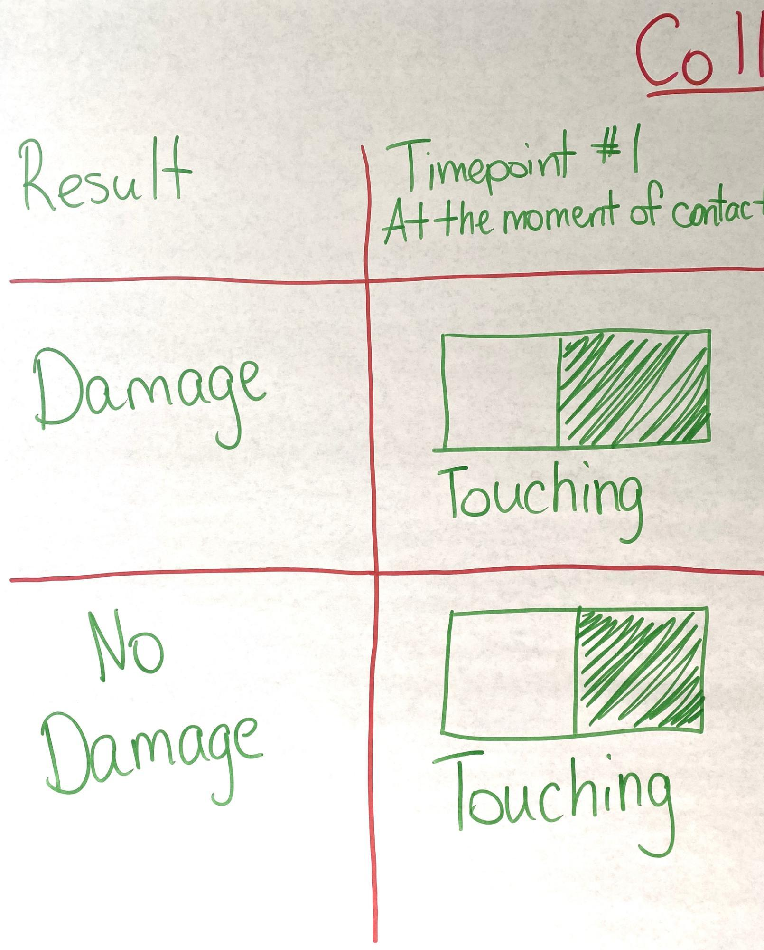
  Switch to time point 2. Again direct students to look at their handouts.  Possible areas of agreement  - The damaged item has permanent damage.  - The damaged item is either bent, cracked, or broken.  Possible areas of disagreement  - We aren’t sure if there is anything visibly different a split second later for the collision that results in no damage.  - When damage occurs, does damage start a split second after contact or bit before or a bit later? | 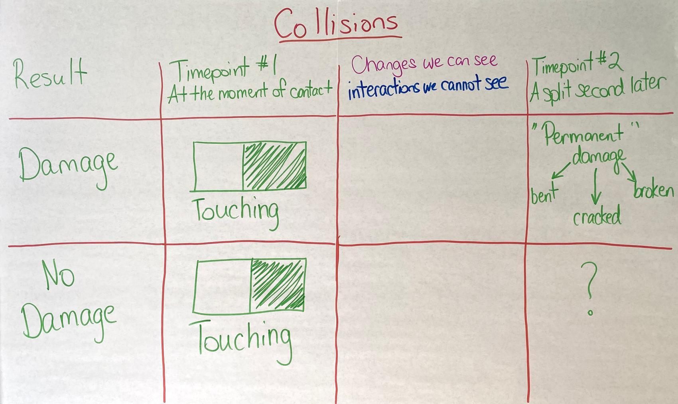
  Potential student responses for changes we see in a collision with damage  - bending  - popping  - breaking  - shattering  - fracturing (may also be represented by some students as an interaction we cannot see)  - pushing or forces (may also be represented by some students as an interaction we cannot see)  Potential student responses for interactions we cannot see in a collision with damage  - fracturing (may also be represented by some students as an interaction we cannot see)  - pushing or forces (may also be represented by some students as an interaction we cannot see)  - energy transfer or flow  - forces  - resisting (or other ideas about some sort of internal material response such as stress)  - particle-level interactions or changes | 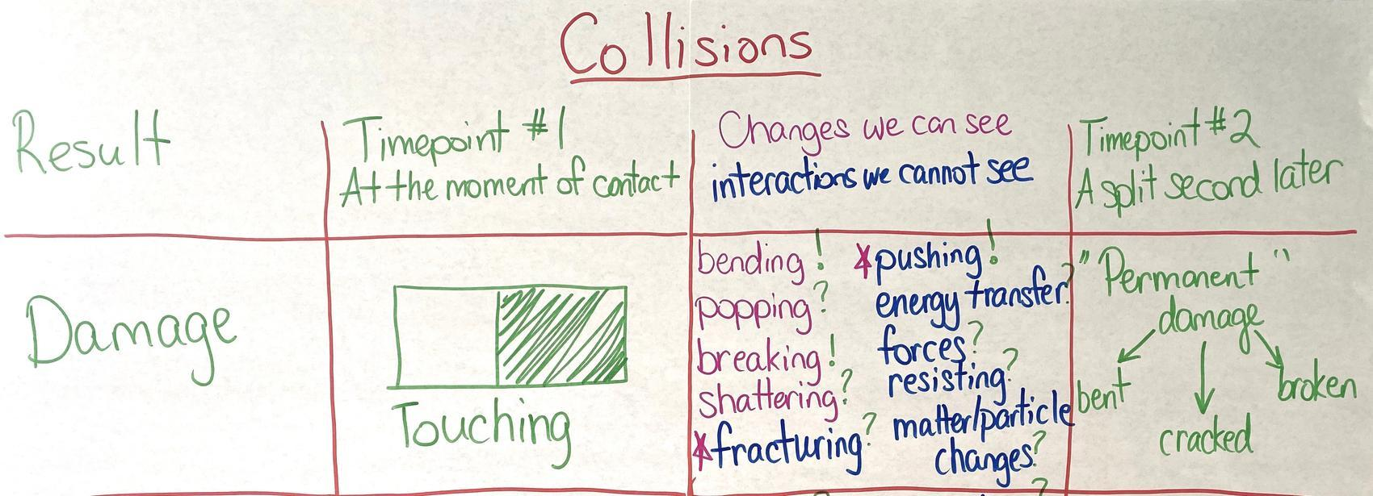
  Potential student responses for changes we see in a collision without damage  - bending  Potential student responses for interactions we cannot see in a collision without damage  - pushing or forces (may also be represented by some students as a change we can see)  - energy transfer or movement  - forces  - resisting (or other ideas about some sort of internal material response such as stress)  - particle-level interactions or changes  - fracturing at a scale smaller than we can see (to account for the idea that there might be damage that we can’t see which helps explain why things wear out over time) | 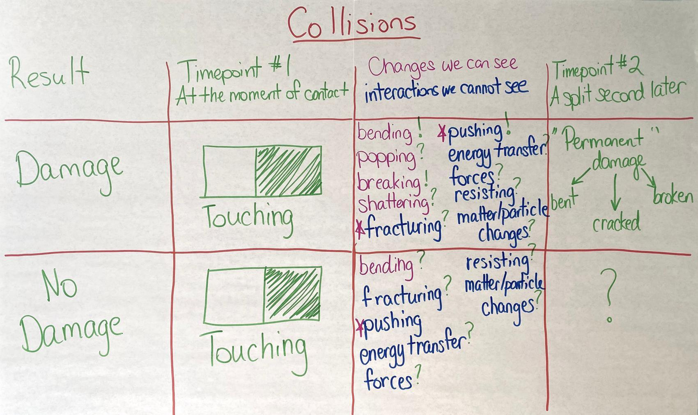

9 · DETERMINE FACTORS AND VARIABLES THAT AFFECT DAMAGE | 5 min
MATERIALS: science notebook, Factors and Variables poster, markers
Show slide N. Have students look back at the Patterns in collisions T-chart in their notebooks.

Create a public record of students’ ideas. Display the Factors and Variables poster.

Say, This will be a record of our initial ideas, and even though we might all agree on some of these being important variables, we don’t yet know how important each one is or which variables or factors make the biggest difference, so I want to put a question mark next to each to indicate that as we quickly record a running list of different possibilities you share.

If students become stuck on wanting to not add a question mark to a particular idea that is shared (e.g., we are all certain that mass is an important factor), ask questions such as these:
- Is X factor or variable more influential in a collision than Y factor or variable?
- So is this factor or variable more important than another factor or variable in a collision?
- Would this factor or variable still have as much of an impact on the outcome as this other factor or variable. What if we changed only this one variable instead of the other or vice versa?

Record student ideas. Students might suggest these ideas:
- speed of the moving object(s)
- size, weight, or mass of the moving object(s)
- shape of the objects
- material those objects are made of
- how hard or soft those objects are
- the angle they hit each other from
- any padding or protective material around either object

At the end of the period, ask students to think more about what factors and variables that are not on our chart might have an affect on the outcome of a collision. Students can ask family, friends, or community about what they think affects damage in a collision if they need more ideas.

It is OK if you do not complete this chart during this class period. It will be revisited at the beginning of day 3.

ADDITIONAL GUIDANCE | Students may begin to compare collision types A and B. This is fine, however, remind them that we are focusing on the cause of the damage or no damage that is done in the collision. Here are some questions you can use:  - Would it always get damaged like this? What factors could cause this to change whether it is damaged?  - What variables would cause this to get more or less damaged?  - What about the object or the setup might affect the amount of damage?  - If we were to change this object to another object, what would we say makes this object easier or harder to damage?

End of day 2
10 · NAVIGATION | 3 min
MATERIALS: Science Classroom Norms, science notebook
Choose a norm to work on today. Display slide O. Tell students, We will spend all day in our Scientists Circle again, working on turning our ideas into questions that we can investigate. Direct them to look over the Classroom Norms chart again. Ask students to nominate a norm that the class should work on as a group. Take a vote and choose a norm to focus on together today.

Say, What strategies can we use to stick to this norm together? Solicit 2-3 student ideas before revising the Factors and Variables poster.

11 · REVISIT FACTORS AND VARIABLES POSTER | 7 min
MATERIALS: science notebook, 1-2 index cards, marker, Factors and Variables poster
Project slide P. Revisit the Factors and Variables poster with students. Ask if they have identified any other factors that may affect damage in a collision. Record student ideas on the poster.

Write additional questions individually. Project slide Q. Pass out 1-2 index cards or sticky notes to each student. Remind them that though we generated questions last time based on what was happening during the collision, they may have new questions about some of these variables and factors from today. Direct students to look back at their Initial Collision Questions notebook page and the Factors and Variables poster. Ask students to use a marker to write on the sticky notes or index cards one or two questions they have developed, one question per card. They should write their questions so they are big and bold. We want to be able to see the questions clearly. Remind students that it will be part of our mission over the next few weeks to try to answer these questions as well as the ones they wrote last time.

12 · DRIVING QUESTION BOARD AND IDEAS FOR INVESTIGATIONS | 28 min
MATERIALS: Initial Model: Objects During Collisions, Object Interactions During A Collision, science notebook, Driving Question Board, Consensus Model for Collisions poster, index cards, tape, chart paper, markers
Start our Driving Question Board (DQB). Before class begins, be sure to have the DQB set up in the room. Place the Consensus Model for Collisions poster near the DQB. Say, We have been analyzing different types of collisions and the results of those collisions. We have identified possible variables and factors that contribute to damage or no damage, and we want to find out exactly how those collisions cause damage.  Write the unit question at the top of the DQB: “Why do things sometimes get damaged when they hit each other?” Give students a moment to gather their index cards from the last activity and record any new questions on new index cards they may have related to collisions.  Gather in a Scientists Circle around the DQB. Display slide R. Instruct students that when they have their questions ready, they need to bring them and chairs to meet in a Scientists Circle around the DQB. Explain to students how you will create the DQB (also shown on slide R):  - The first student reads a question aloud to the class, then posts it on the DQB.  - Students who are listening should raise their hands if they have a question that relates to the question that was just read aloud.  - The first student selects the next student whose hand is raised.  - The second student reads a question, says why or how it relates, and posts it near the question it most relates to on the DQB.  - That student selects the next student.  - If another student has shared the same question that you have, try to share a different question that has not been shared.  - We will continue until everyone has at least one question on the DQB.✱  Organize questions into categories. As students share, questions will naturally start clustering into similar parts of the model or similar questions. Once students have finished their sharing, ask them to identify the categories of questions and write these category names near each cluster of questions. To stay on track, save at least 8 minutes of class time for students to think about investigations. See the image in the step above for an example of student questions divided into potential categories. If you are short on time, create candidate categories yourself after this lesson, post them, and then share these with students at the start of the next class, asking them to make any suggested modifications to these if they think they don’t quite capture the themes that emerged on the board.  An example of a Driving Question Board created using student questions from a pilot classroom is below.  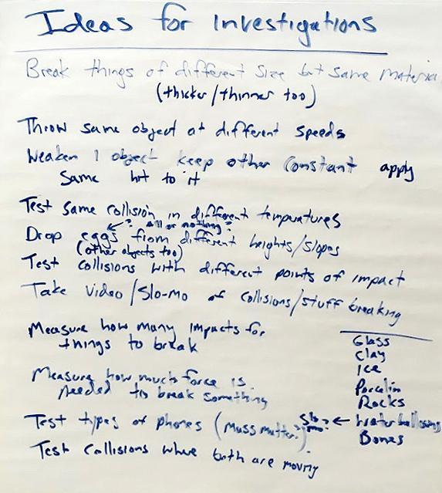  Stay in a Scientists Circle to brainstorm investigations. Show slide S. Read the slide. Give students about five minutes to individually record in their notebooks some ideas for future investigations. As students are doing this, create a new poster titled “Ideas for Investigations and Data We Need.” Put this right next to the DQB.  Tell students that you are going to record their ideas and that you want everyone’s idea to be represented. As students are sharing their ideas, underline repeated statements to keep track of common ideas among students. Emphasize that the list is what we want to do that we think might help us answer our questions and that we may need to add to this list and update our DQB throughout the unit as we go. | ✱ SUPPORTING STUDENTS IN ENGAGING IN ASKING QUESTIONS AND DEFINING PROBLEMS  If a student forgets to explain why or how their question is linked to someone else’s question, press that student to try to talk through their own thinking. This is a key way to emphasize the importance of listening to and building off each other’s ideas and to help scaffold student thinking.  If students can’t figure out which question to connect theirs to, encourage them to ask the class for help. After an idea is shared, ask the original presenter if there is agreement and why, and then post the question.  If any student has questions that are similar to (or the same as) others that are posted and has no new ones, have the student place one of their questions on top of the question that is similar so other students can visually see how many of the questions are the same or related. Emphasize that this provides us with evidence of where many people are thinking about similar things.
  ASSESSMENT OPPORTUNITY | Building towards: 1.B Ask questions that arise from observations of collisions between two objects in order to seek additional information about factors (causes) that might affect the outcome (effect) of such collisions.  What to listen for:  - A variety of open-ended questions (how and why), instead of close-ended questions (yes and no)  - One or more questions about the factors and variables that affect the amount of damage in a collision  - One or more questions about the changes and/or interactions occurring during a collision (between time point 1 and time point 2)  What to do:  - If students are asking mostly closed questions, you can provide a copy of the questions on the DQB and ask them to work on refining three or more of these questions so they become how and why questions that can still also address parts of the original yes or no question. This could be an in-class or home learning assignment. For practice (e.g., exit or entrance ticket) the following two questions can be answered at the end or start of any future lessons:  - What questions were raised for us (now or from the end of the last class)?  - How might we investigate one or more of those questions using equipment in our classroom to collect our own data or using data that other people have collected in other places?  - If students are not asking about the factors and variables that may contribute to damage, have students refer to the Patterns in collisions chart they created in their notebooks and think about how changing one of those factors or variables might impact the severity of the collision. This also could be a recurring home learning assignment for students to continue to discuss with family, friends, and community, as suggested at the end of day 1 of this lesson.  - If students are not asking questions about the changes or interactions occurring between time point 1 and time point 2, have students refer to the initial consensus model and/or Initial Model: Objects During Collisions and Object Interactions During A Collision to identify areas of uncertainty.
  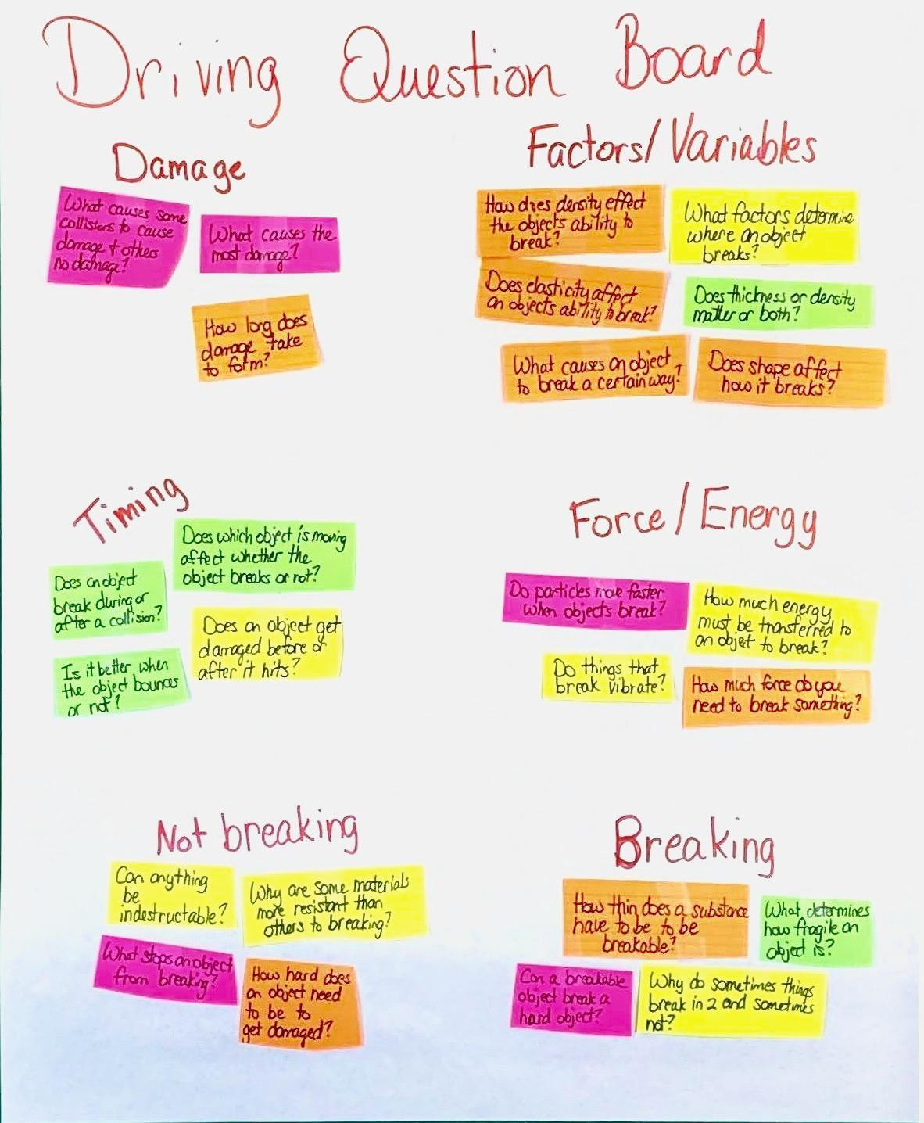
  SCIENTISTS CIRCLE | One way to ensure that all student ideas are shared and get up on the board or poster is to pass a marker to the first person nearest you in the circle. The student with the marker should share one idea. Write it on the board or poster. Once that student sees that you have almost finished writing it, that student should pass the marker to the next student. The second student then shares an idea. If the idea is on the poster already, the student should say which idea is similar and how it is similar. Put a tally mark next to that idea. In this way, the marker is passed all around the circle and all students have a chance to have their thinking represented on this poster. Remind students that if they have additional ideas that don’t end up on the poster, they should jot them down now and then raise a hand to share only after the marker makes it all the way around the circle.

13 · NAVIGATE TO NEXT LESSON | 2 min
MATERIALS: None
Forecast that we will investigate our questions. Display slide T. Say, Wow. We have accomplished so much. We now have a broad mission to accomplish as a class. That is thanks to all the questions you shared and how you connected them together. These questions really represent what it is we hope to be able to figure out. And we have a lot of ideas for investigations we could do to try to figure this all out. I am very excited for us to be able to get started on investigating all of this. Let’s plan to start exploring some of those questions and ideas in our next lesson.

14 · REVISITING NORMS | 3 min
MATERIALS: Science Classroom Norms, science notebook
Debrief how we did with our focal norm. Display slide U. Have students turn and talk and share how they did with the norm they selected. Ask students, How did the norms help us talk together and come up with some ideas of what we think is happening? Allow a few students to share and tell students they will continue to work on the norms.

15 · ADD TO THE TABLE OF CONTENTS | 2 min
MATERIALS: science notebook, chart paper, markers
Update the table of contents with students. Say, But before we start on one of our investigation ideas, let’s organize the work we have done so far. Take any remaining time to have students update their table of contents and page numbering to include references to all the work they have done so far. Develop a sample table of contents with students on chart paper to show one way to name the work they have in their notebooks and reference the related pages it is on. If you run out of time for this today, make sure to do this before the start of the next lesson the next time you meet.

SCIENCE NOTEBOOK | If this is the first unit of your 8th grade course, you may want to remind students to update their notebooks on days when you have some extra time available. It is recommended that you make time to have students update the table of contents whenever they are adding to their Progress Tracker for the unit. This will happen individually at the end of most lessons and collectively at other key points in the unit. This periodic time for organization helps students look back on the trajectory of their learning journey. For many students, this is a helpful way to support coherence. If you run out of time for this at the end of this class period, it can be moved to the beginning of the next class.

Additional Lesson 1 Teacher Guidance
SUPPORTING STUDENTS IN MAKING CONNECTIONS IN ELA | CCSS.ELA-LITERACY.SL.8.1.C Pose questions that connect the ideas of several speakers and respond to others' questions and comments with relevant evidence, observations, and ideas.  When the class is building the Driving Question Board (DQB), if a student forgets to explain why or how their question is linked to someone else’s question, press that student to try to talk through their own thinking. This is a key way to emphasize the importance of listening to and building off of each other’s ideas and to help scaffold student thinking.  Don’t worry if some questions are raised that are not part of topics in this unit. Over time, students will get better and better at forming testable questions within the scope of the driving question. This type of activity gives them practice at doing that.  If students can’t figure out which question to connect theirs to, encourage them to ask the class for help. After an idea is shared, ask the original presenter if there is agreement and why, and then post the question.

